SIMATS ENGINEERING (SAVEETHA SCHOOL OF ENGINEERING)
Department of Computer Science and Engineering

ASSESSMENT TOOL 2– Concept Mapping

Course Code: | CSA0306 | Course Title: | Data Structures
CO Assessed: | CO1 – Imitation (BL3, BL4) | Assessment: | Assessment Tool 2 – Concept Mapping
Weightage: | 10% of CIA | Total Marks: | 100
CO1 Statement: | Basics, Data, Data object, Data structure, Abstract Data Types (ADT), realization of ADT in ‘C’, Primitive and non-primitive data structure, Linear and non-linear data structure Arrays & Recursion, Performance analysis and Measurement: Time and space analysis of algorithms, Average, best and worst-case analysis.
Student Name: | Variganji Sumanth Babu | Reg. No.: | 192524447
Section / Batch: | B. TECH – AI & DS | Date: | 15 July 2026

Code of Conduct
I Variganji Sumanth Babu / 192524447, certify that this submission is my original work and that I have adhered to the guidelines specified for this assessment. I understand that any violation of academic integrity rules will result in disciplinary action.
Signature of the Student:
Instructions
- This test contains 2 concept mapping, Total: 100 Marks.
- Evaluation of Answer Quality -Checking whether the answer includes: Concept Identification , Linkages, Organization, Integration of Literature, and Clarity
- No DTP printouts or electronic devices permitted. They should provide materials in PDF format.

Rubrics

Questions | Problem Understanding | Method Selection | Solution Process | Accuracy of Calculation | Interpretation of Results | Total Marks
Q1
Q2

Annexure A – Concept Mapping

Q1 A smart healthcare system processes large volumes of patient data such as temperature readings, medical history, and diagnostic details. Construct a concept map linking the progression from Data → Data Object → Data Structure → Abstract Data Type (ADT) → Implementation in C. Identify relevant sub-concepts such as structures, pointers, and operations, and establish meaningful relationships among them. Organize the concept map hierarchically and justify how each level contributes to efficient data organization, processing, and improved system performance.

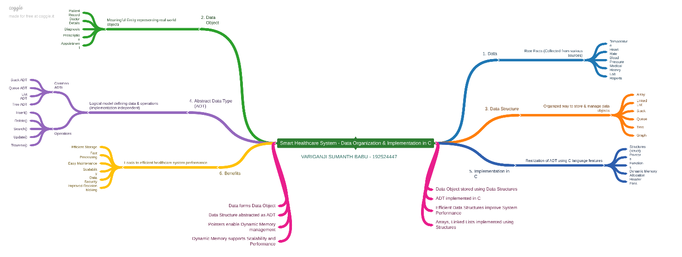

https://coggle.it/diagram/al2pkLIYffyQ4GAt/t/smart-healthcare-system-organization-implementation-in-c/Hbuey2ohAA0RIVNjPhxpmF5Doq2GKAENktOj496U40c

https://drive.google.com/file/d/1UHZqHX6Cwn4dFrpCSJBYpNJyaYUQQ-Io/view?usp=sharing
https://drive.google.com/file/d/1QLFFDqI2uBFB_q7zdc4Ioqg5fobC0IJY/view?usp=sharing

https://drive.google.com/drive/folders/1yVAvLPaSlMeRNxfGa-Z7lg1XjKw0k6AF?usp=drive_link

https://github.com/192524447/CSA0306-DATA-STRUCTURES.git

Q12 A ride-sharing application must manage user requests, driver allocation, and route mapping simultaneously. Construct a concept map connecting ADT → Linear Structures → Non-Linear Structures
→ Algorithms → Performance Analysis → Efficiency. Demonstrate how these concepts are integrated into a real-world system. Justify the role of each component in achieving efficient and scalable performance.

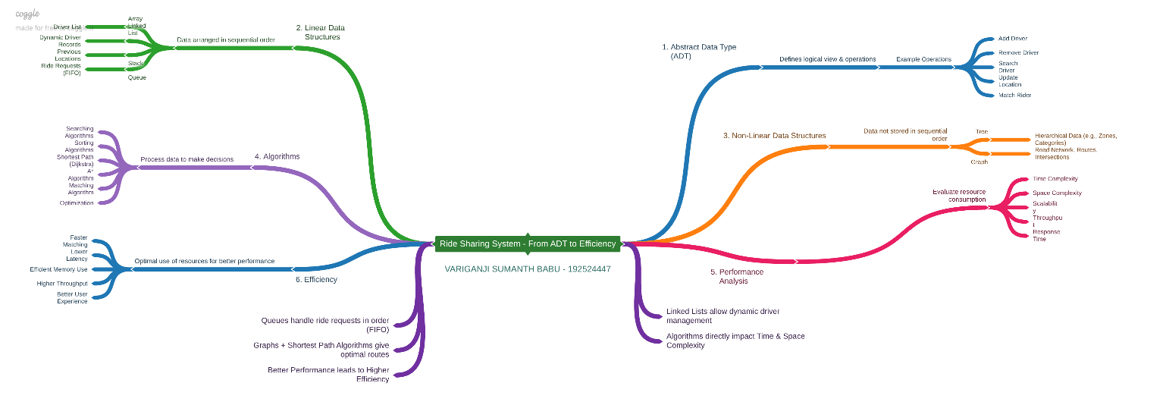

https://coggle.it/diagram/al2r1neKuqyYnOV8/t/ride-sharing-system-from-adt-to efficiency/kYEEmZP8mwTu5wQbDRI-xYfHfLVUqDobM_UwRsLTDgo

https://drive.google.com/file/d/1ww4iGAWZHmetUEIiU5-XHcncrFhWipN1/view?usp=sharing
https://drive.google.com/file/d/1gGIESJOf8B1jID2-V-Bi8XEIya0_sUym/view?usp=sharing

https://drive.google.com/drive/folders/1yVAvLPaSlMeRNxfGa-Z7lg1XjKw0k6AF?usp=drive_link

https://github.com/192524447/CSA0306-DATA-STRUCTURES.git

